**Sprint 3 Plan**

**PantryPal**

**July 17, 2023 - July 21, 2023**

**Revision: 1.0.0**

**Revision date: July 9, 2023**

**Goal:** Build on the web app so that it is able to take a user input and be able to filter by number of results, only find recipes with ingredients given, while also allowing filters such as a nut-free option.

**User Story:**

* **As a user, I want to be able to see a list of possible ingredients to be able to quickly add ingredients (3)**
  + UI to display possible ingredients **(3)**
* **As a user, I want to filter by the number of results (3)**
  + Number input to set ?n= **(3)**
* **As a user, I want to be able to only find recipes with the ingredients I have (3)**
  + Button to toggle “only ingredients” **(3)**
* **As a user, vegetarian and nut allergies (3)**
  + A Button to toggle for vegetarian options or nut allergies options **(3)**
* **As a user I want to receive responses from the api if my input is invalid so I can correct it (2)**
  + Parse the ingredients from server input (**2)**
* **As a user I want to receive responses from the api for vegetarian options and nut allergies option (3)**
  + Add query for vegetarian options and nut allergies options (**3)**
* **As a user that has nut allergies, I want to be able to only receive recipes that don’t have nuts in them that can be made with the ingredients I input. (6)**
  + Preprocess dataset with nut-free recipes **(3)**
  + Tune model to best generate valid no nut recipes **(3)**

**Team roles:**

* **Sayak:** Product Owner, Frontend Developer
* **Aaron:** Backend Developer
* **Yera:** Frontend Developer
* **Hisham:** Frontend Developer
* **Raghavendra:** Scrum Master, ML engineer
* **Zhengheng:** Scrum Master, ML engineer

**Initial task assignment:**

* **Sayak:** As a user, I want a variety of recipes based off the ingredients I input
* **Aaron:** As a user I want to receive responses from the api for vegetarian options and nut allergies option
* **Yera:** As a user, I want a user interface that has a formatted list of recommendations and also responses for errors that I’ve made
* **Hisham:** As a user, I want a user interface that has a formatted list of recommendations and also responses for errors that I’ve made
* **Raghavendra:** As a user that has nut allergies, I want to be able to only receive recipes that don’t have nuts in them that can be made with the ingredients I input.
* **Zhengheng:** As a user that has nut allergies, I want to be able to only receive recipes that don’t have nuts in them that can be made with the ingredients I input.

**Initial Scrum Board:**

[**https://pantrypal.atlassian.net/jira/software/projects/SCRUM/boards/1**](https://pantrypal.atlassian.net/jira/software/projects/SCRUM/boards/1)

**(Screenshot was taken at the end of the sprint)**

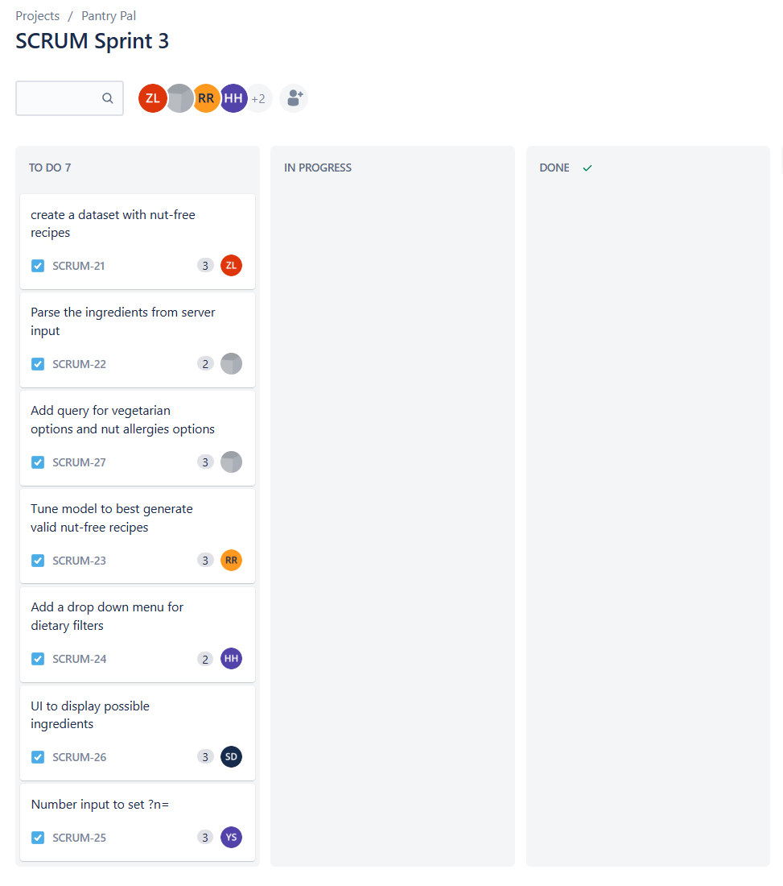

**Chart: (needs to be added later in the sprint review)**

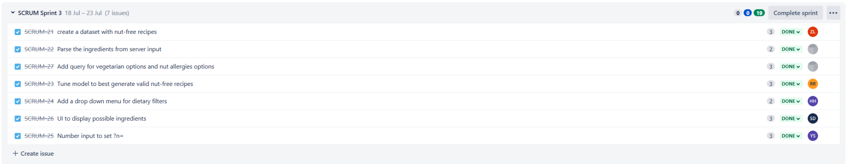

**Scrum Times:**

Mondays: 6-7pm, Wednesdays: 5-6pm, Fridays: 5-6pm